STANDARD OPERATING PROCEDURE: Upgrading Walk-in Monitoring System.

Required Materials:

|  |  |  |
| --- | --- | --- |
| 1 each | Multitech Hub |  |
| 1 each | Power cord for hub and long Ethernet Cable. |  |
| 1 each | Short Ethernet Cable |  |
| 1 Each | 1 Air and 1 Product sensor |  |
| 1 roll | Double-faced mounting tape or squares. As an alternative, the new Gateway hub may be attached with a bracket. |  |
| 1 | Permanent marker to mark “Air” or “Product” on the individual sensors |  |

**Connecting the sensors and gateway to the restaurant network.**

Prior to installation each sensor and gateway hub must be scanned into and connected to the individual restaurant network. This can be done prior to arriving at the restaurant OR at the restaurant location.

Step 1: Connecting the gateway using the Jolt app (on a cell phone).

Using the phone JOLT App, select the individual restaurant by using the following steps.

1. Open the App
2. Select Settings
3. Select Location (the app will load the appropriate location.
4. Select Sensors
5. Select the “+” at the top of the screen.
6. Select “setup Gateway”
7. Select “Lorawan”
8. Scan the QR code on the side of the Multitech gateway.
9. Select the “Install complete” bar at the bottom of the screen.

The same process may be followed using the restaurant JOLT ipad.

1. Open the Jolt App on the ipad.
2. Log-in using your login ID and PIN.
3. Select Sensors
4. “Select the “+” at the top of the screen.
5. All other steps are the same.

Step 2: Connecting each individual sensor to the network:

1. Open the App
2. Select Settings
3. Select Location (the app will load the appropriate location.
4. Select Sensors
5. Select the “+” at the top of the screen.
6. Select “Connect Sensor”
7. Scan the QR code on the back of the sensor.
8. Name the sensor as Product or Air by entering it into the screen at the top of the phone.
9. Write “Air” or Product” on the front of the sensor with a permanent marker.

The same process may be followed using the restaurant JOLT ipad.

1. Open the Jolt App on the ipad.
2. Log-in using your login ID and PIN.
3. Select Sensors
4. “Select the “+” at the top of the screen.
5. All other steps are the same.

**Your login information for the Jolt iPad App is:**

**TRCA Admin**

**PIN is 1234**

**Installing the Gateway Hub and Sensors into the individual restaurant. This is done AFTER the hub and sensors have been scanned into the network for the individual restaurant.**

Step 1: Locate Ethernet port to be used for Hub.

Locate an area where the HUB can be installed. The HUB requires power and data to operate, and it must be located and mounted in a location that is within 20-25 feet of the door to the walk-in refrigerator. If the restaurant has an older style black hub, the same general area should be appropriate for the new hub.

|  |  |
| --- | --- |
| This is what the older style Bluetooth hub looks like. It may be removed after activation. |  |

In most restaurants we have placed the new hub behind the manager’s PC (most are mounted below the shelf). We have been using double sided tape. You may use the included bracket and screws if that makes more sense.

Once you’ve located an appropriate place with power and data, connect the long ethernet cable to the HUB and run it to a numbered port (take note of the port number). Do not power on the hub until after the IT closet is set up.

Step 2: IT Closet set-up.

Use the smaller ethernet cable to patch the numbered port into the Skill-it network.

If it’s an older system with a Dell switch, connect the cable into any open port between #3 and #16.,

If it’s a newer system (white Fortinet) the cable should plug into Port #11.

Step 3: Power up the hub.

Plug in the hub. After a minute or two, the second light, marked Lora, should glow a solid green.

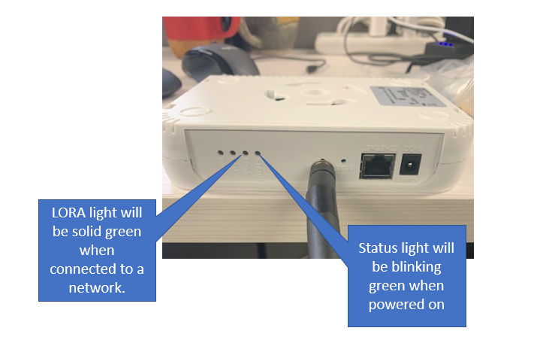

Step 4: Place the magnetic sensors.

Remove the battery protective strips from each sensor. Each sensor should be marked with the restaurant number and will say “air” or “product”. They are specific to each individual restaurant.

* The Air sensor should be placed on the ceiling, near where the older temp probe is hanging. It should be about midway between the door and the fan, and away from the light. If you cannot locate the older probe don’t worry about it. You don’t need to remove the older probe. Simply place the sensor per the above notes.
* The Product sensor should be placed on the wall behind where the shredded meats and sauces are stored. Place it so that it is partially protected by one of the shelving poles so that it is less likely to be bumped.

Step 5: Validation

* Within 15 minutes the sensors should be reporting readings to the system (visible on the Jolt webpage). This is visible at the restaurant by asking the manager on duty to log into the jolt website and go to the following pages:
  + Slide the curser to the left until the menu banner appears.
  + Select Sensors
  + Select Reports.
  + Temperature graphs should appear within 15 minutes of installation.
* Sensor readings will also be visible on the Jolt telephone App.
  + Select Sensors
  + Readings will be visible for both sensors after connection.
* You can also call my cell for validation, and I can look at the sensor readings:
  + Cell: 801-833-4962,

Thank you!

Jerry